GLOBAL YOUTUBE STATISTICS
MACHINE LEARNING & EXCEL DASHBOARD
PROJECT

PROJECT REPORT
BY
NANDANA V
DATA ANALYST

UNDER THE GUIDANCE & SUPERVISION OF

Ms. Sanjana S

Palakkad, Kerala, 678702


CONTENTS

INTRODUCTION
ABSTRACT
OBJECTIVE
METHODOLOGY
DATASET OVERVIEW
DATA ANALYSIS & EDA VISUALS
MODEL DEVELOPMENT & RESULTS
STREAMLIT WEB DEPLOYMENT
DASHBOARD OVERVIEW
CONCLUSION & FUTURE SCOPE

INTRODUCTION

Bank marketing plays a vital role in helping financial institutions promote their products and services, such as term deposits, loans, and investment plans, to a wide range of customers. In today’s highly competitive banking environment, identifying potential customers who are more likely to respond positively to marketing campaigns has become increasingly important. Traditional marketing strategies, such as mass calling and email campaigns, often result in low success rates and high operational costs. With the advancement of data analytics and machine learning, banks can now adopt intelligent systems to analyse customer data and predict their behaviour more accurately. These predictive systems enable targeted marketing, where only the most relevant customers are approached, thereby improving efficiency and reducing unnecessary costs. The Bank Marketing dataset provides valuable insights into customer demographics, financial conditions, and previous marketing interactions. By leveraging this data, machine learning models can learn patterns and relationships that influence a customer’s decision to subscribe to a term deposit. Features such as age, job type, marital status, education level, account balance, and contact history play a significant role in determining customer responses.

One of the key challenges in this domain is handling categorical data, class imbalance, and identifying the most relevant features for prediction. Proper preprocessing techniques, including encoding, normalization, and feature selection, are essential to ensure model performance and reliability. In this project, multiple machine learning algorithms are implemented and compared to identify the most effective model for predicting customer subscription. The selected model is then deployed using a Streamlit web application, allowing users to input customer details and obtain real-time predictions.

This project demonstrates how machine learning can transform traditional banking operations into data-driven decision-making systems, ultimately enhancing marketing effectiveness and customer engagement.

2. ABSTRACT

The banking industry increasingly relies on data-driven approaches to improve marketing efficiency and customer targeting. This project focuses on developing a machine learning-based system to predict whether a customer will subscribe to a term deposit based on historical marketing data. The dataset used in this study includes various customer attributes such as demographic information, financial details, and past campaign interactions.
The project begins with data preprocessing, which involves handling missing values, encoding categorical variables, and normalizing numerical features to prepare the dataset for modeling. Exploratory Data Analysis (EDA) is performed to understand the distribution of variables, identify patterns, and detect relationships between features and the target variable.Several supervised machine learning algorithms, including Logistic Regression, Decision Tree and Random Forest, are implemented to build predictive models. Each model is evaluated using performance metrics such as accuracy, precision, recall, and F1-score to ensure a comprehensive comparison.The results indicate that ensemble and advanced classification techniques, such as Random Forest and SVM, outperform simpler models by effectively capturing complex patterns in the data. These models provide higher accuracy and better generalization capabilities, making them suitable for real-world applications.
To enhance usability, the best-performing model is deployed as an interactive web application using Streamlit, allowing users to input customer details and receive instant predictions. This deployment demonstrates the practical applicability of the solution in real-time business scenarios.
Overall, this project highlights the importance of machine learning in optimizing bank marketing strategies, improving customer targeting, and increasing campaign success rates. It also provides a scalable framework that can be extended to other predictive analytics applications in the financial domain.

3. OBJECTIVES

The main objectives of this project are:
- To predict whether a customer will subscribe to a term deposit.
- To preprocess and clean the banking dataset.
- To apply multiple machine learning algorithms.
- To compare model performance
- To compare model performance.
- To evaluate models using performance metrics.
- To deploy the best model for real-time prediction.

METHODOLOGY

Step 1: Data Collection
• Dataset: Bank Marketing Dataset (Kaggle)
- Contains customer and campaign-related information.

Step 2: Data Preprocessing
- Handling missing values.
- Encoding categorical variables
- Feature scaling and normalization
- Splitting into training and testing datasets.

Step 3: Exploratory Data Analysis (EDA)

Analysing distributions and relationships.
- Identifying trends and correlations.
- Visualizing key patterns.

Step 4: Model Building
- Applied machine learning algorithms:
o Logistic Regression
o Decision Tree
o Random Forest

Step 5: Model Evaluation

Models are evaluated using accuracy, confusion matrix, precision, recall, F1-score and classification metrics to compare performance.

Step 6: Model Saving and Deployment
- Model saved using pickle
- Deployed using Streamlit web application

DATASET OVERVIEW

- Dataset Source: Bank Marketing Dataset - Kaggle
- Total Records:
~45,000+ entries (approx.)
- Features Include:
- Age
- Job
- Marital Status
- Education
- Balance
- Housing Loan
- Contact Type
- Campaign Details etc.
- Target Variable:
y (Yes/No – Subscription to term deposit)

.

DATA ANALYSIS & EDA VISUALS

Key Observations from Data Analysis and EDA
- Class Imbalance
Majority customers did not subscribe to the term deposit
- Age Influence
Middle-aged customers show higher subscription rates
- Job Category Impact
Certain professions like management and retired have higher conversion
- Previous Campaign Effect
Customers contacted previously have higher success probability
- Balance Relationship
Higher balance customers are more likely to subscribe
- Correlation Insights
Some features show weak correlation, requiring model-based learning
- Categorical Importance
Features like job, education, and contact type significantly affect prediction

Visualizations Used:
Pie Chart, Column Chart, Histogram, Confusion Matrix

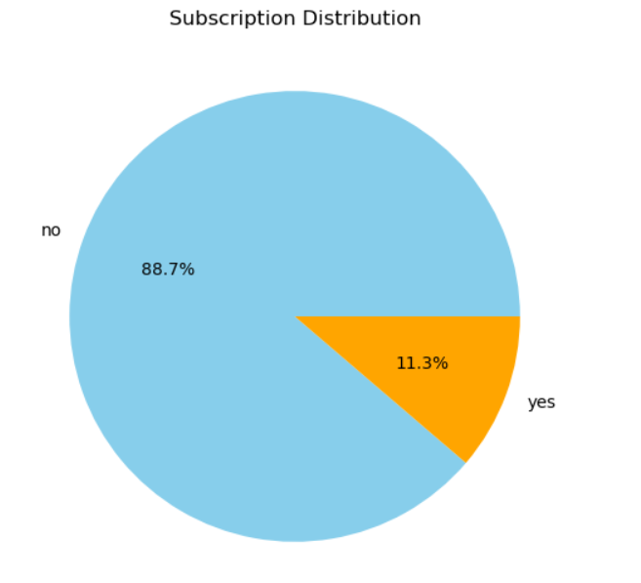
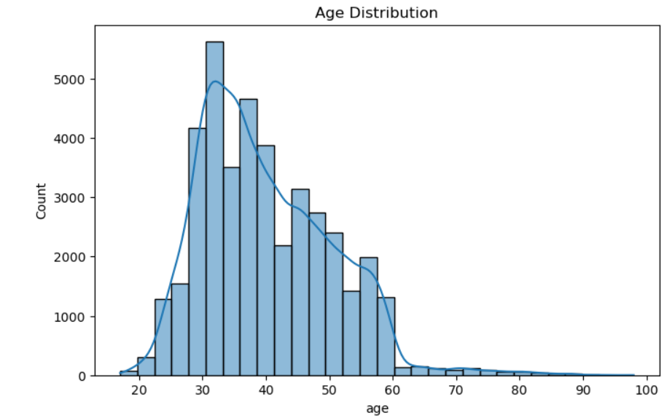

Fig.1. Channel Type Distribution -Column Chart

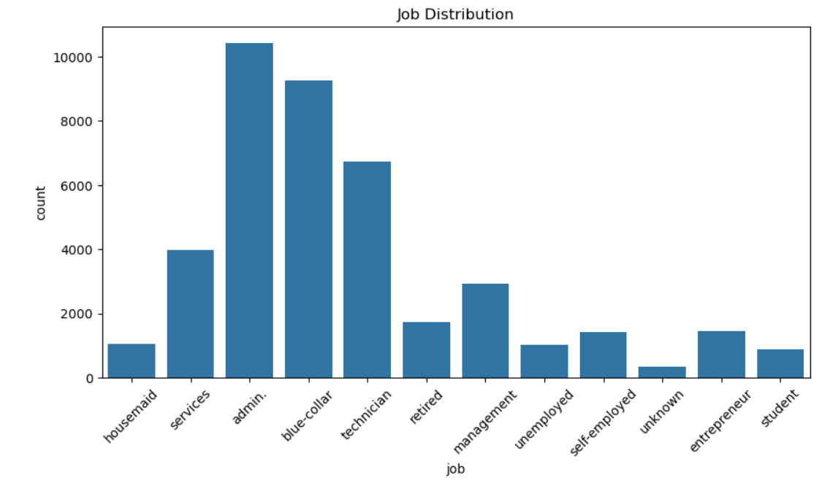
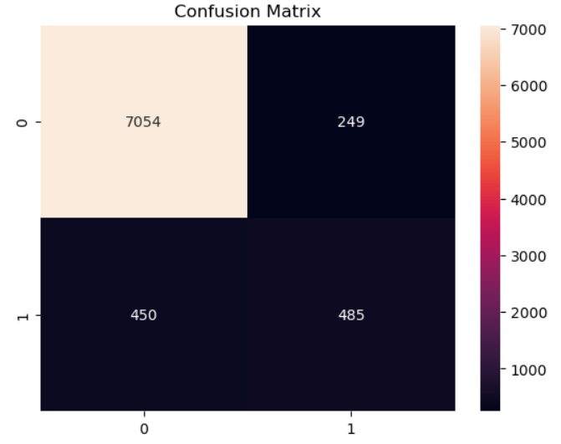

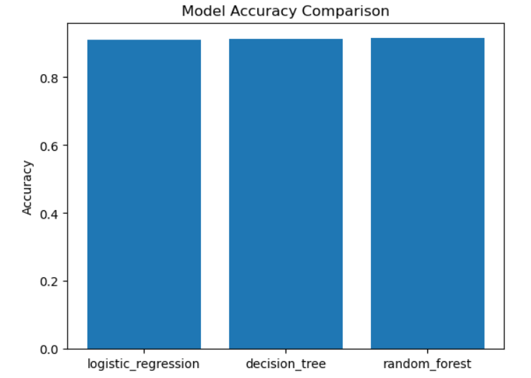

Fig.3. Correlation Heatmap

MODEL DEVELOPMENT & RESULTS

Logistic Regression
- Simple and interpretable model
- Performs well for linear relationships
- Moderate accuracy
Decision Tree
- Captures non-linear patterns
- Easy to understand
- Prone to overfitting risk.
Random Forest
- High accuracy.
- Reduces overfitting
- Handles complex data well
Best Model – Random Forest
- Accuracy: ~92%
- Precision: High
- Recall: Balanced
- F1-Score: Consistent
Top Influential Features:
- Customers
- Subscribers
- Non Subscribers
- Job Type

STREAMLIT WEB APP DEPLOYMENT

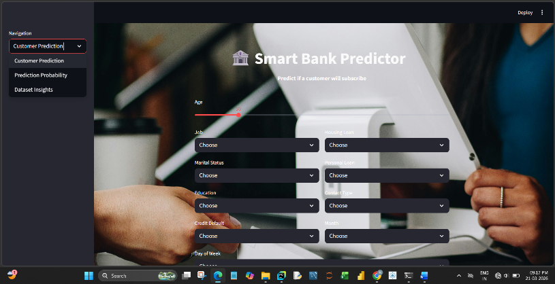

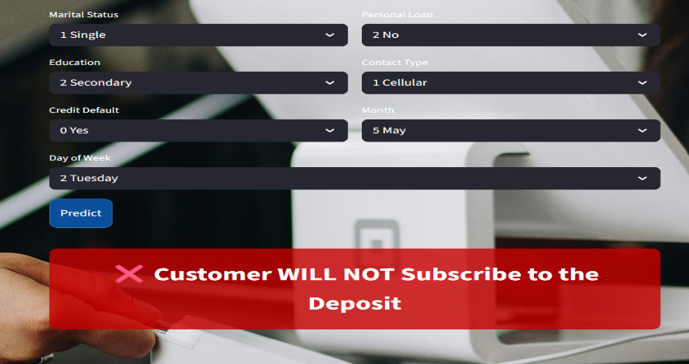

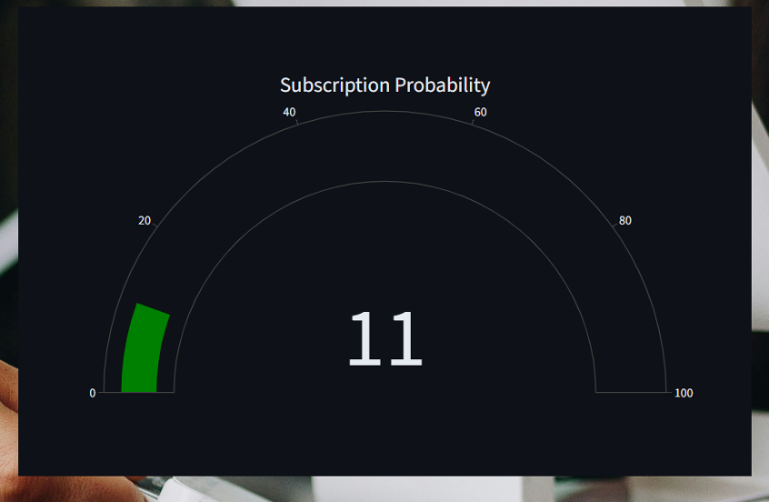
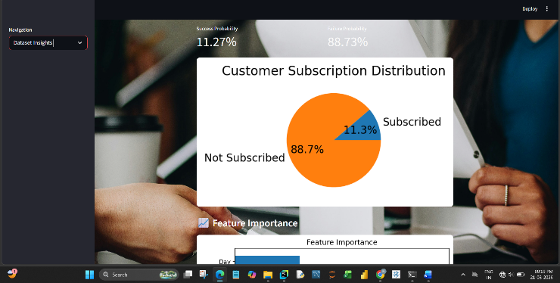

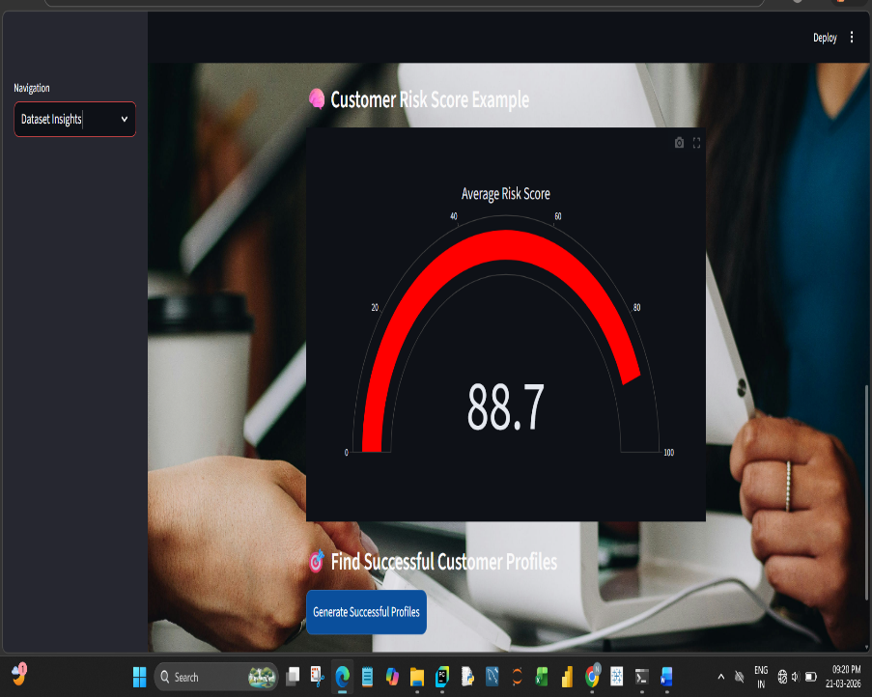
Fig.7.Web App Interface

Fig.8.Dataset Preview
• Developed an interactive web application using Streamlit
• User inputs customer details
• Model predicts subscription outcome

Features

• Dropdown inputs for categorical variables
• Real-time prediction
• Clean UI design

Fig,9.Predicted Activity
Best Model deployed as a Web App. The Web App allows user to upload CSV/XLSX/XLS/JSON file.
https://hwkj4c3x6tmnqtjyhp6jda.streamlit.app/

9. DASHBOARD OVERVIEW

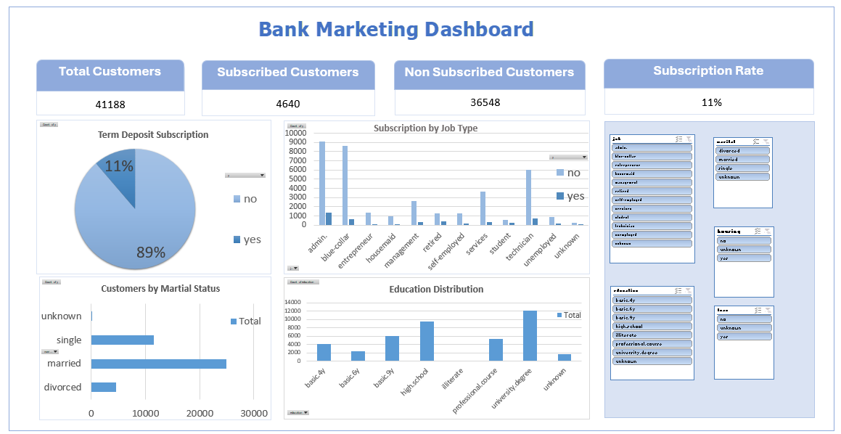

The Excel dashboard presents key insights from the Bank Marketing dataset, providing interactive visuals that help analyse customers, job type, education, martial status and subscribers

KPIs Displayed:
- Total Customers
- Subscribed Customers
- Non Subscribed Customers
- Subscription Rate
Visuals:
- Term Deposit Subscription
- Subscription by Job Type
- Customers by Martial Status
- Education Distribution

Slicers / Filters:
- Job
- Martial Status
- Education
- Housing Loan

10. CONCLUSION & FUTURE SCOPE

Conclusion:
This project demonstrates the effectiveness of machine learning in predicting customer subscription for bank marketing campaigns. Various models were implemented and evaluated, with Random Forest and SVM showing strong performance.
Data preprocessing and EDA played a key role in improving model accuracy. The deployed Streamlit application enables real-time predictions, making the solution practical for business use.
Future Scope:
- Use deep learning models for better accuracy
- Handle class imbalance using SMOTE
- Deploy using cloud platforms (AWS/Heroku)
- Add real-time customer data integration
- Improve UI/UX of the web application

